**EXPERIMENT 1**  
  
**Exercise Question 1**: Create a LAN in bus topology using hubs and switches in CPT.

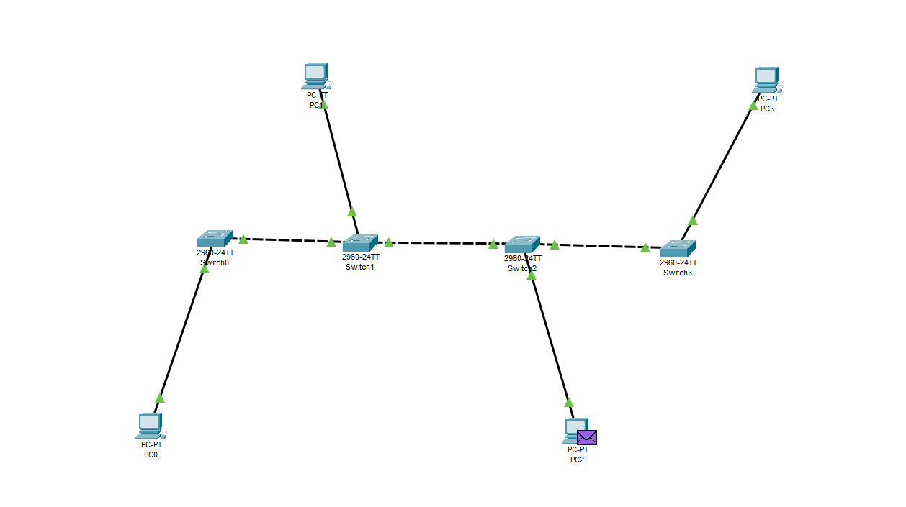

**Exercise Question 2**: Create a LAN in star topology using hubs and switches in CPT.

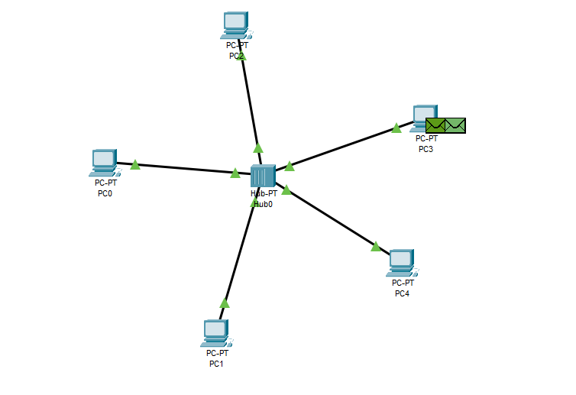

**Exercise Question 3**: Create a LAN in mesh topology using hubs and switches in CPT.

